ASSIGNMENT 4

Team Leader : SAJEETH GURU G P

Team Member 1 : MADHAVAN S

Team Member 2 : ROHITH R

Team Member 3 : SAMSUL GHUDHA A S

1.Create a dockerfile for the jobportal application and deploy it in Docker desktop application.

=>Jobportal Working directory:

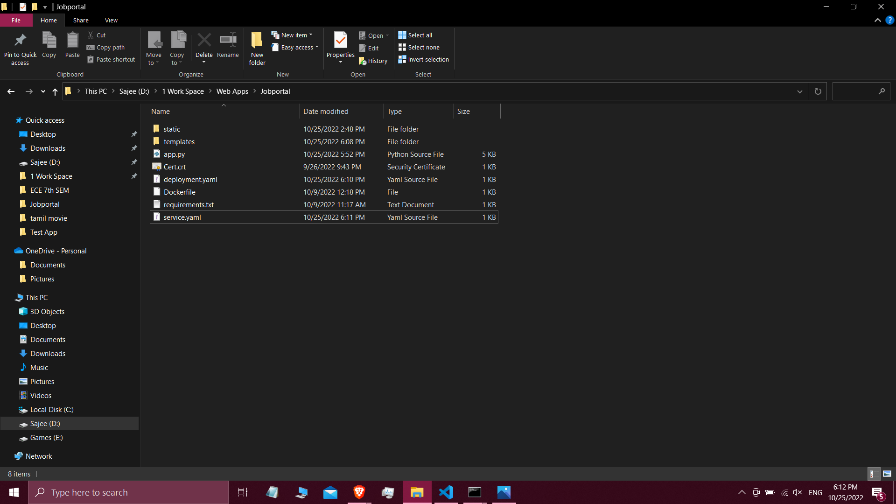

=>Dockerfile:

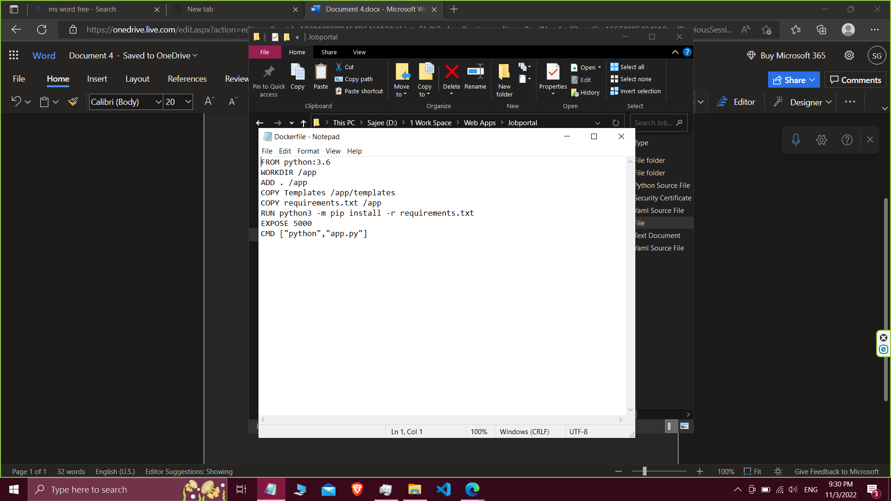

=>Deploy jobportal application to docker desktop:

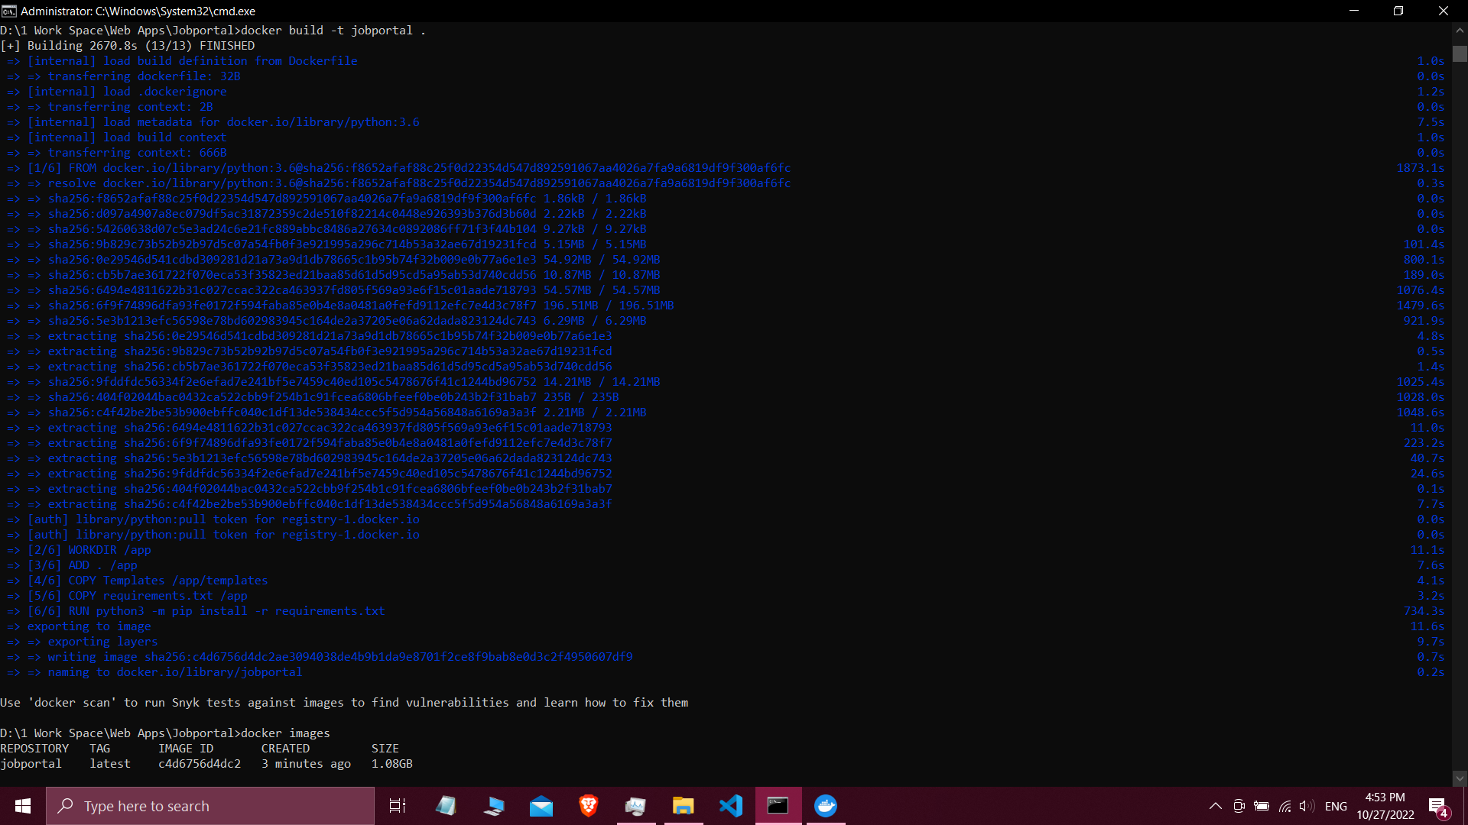

=>running the image from docker desktop:

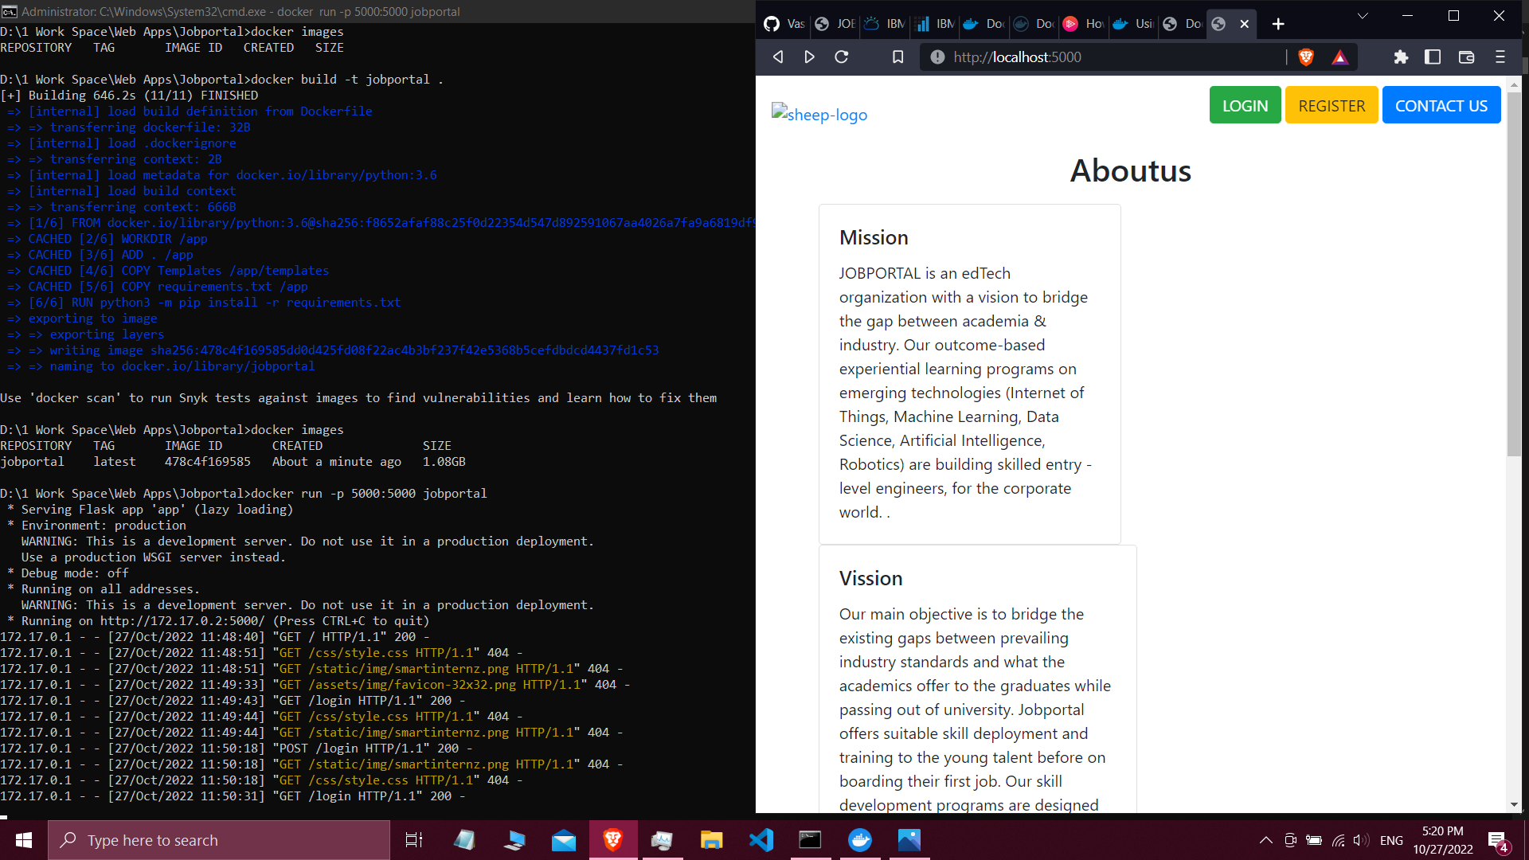

2.Pull an Image from docker hub and run it in docker playground.

=>Pushing image to docker hub

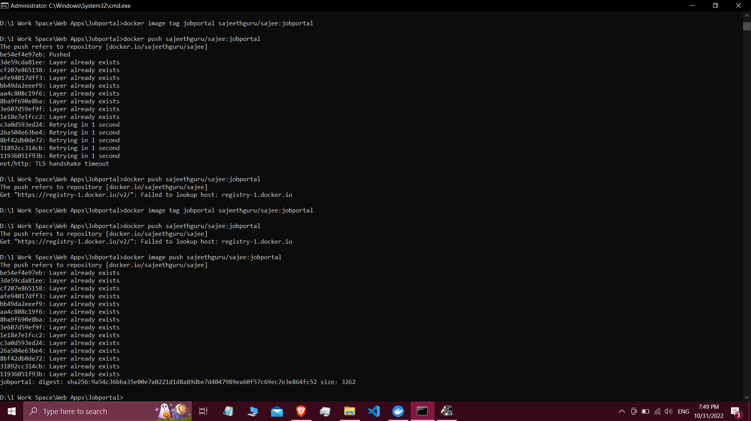

=>Pulling the jobportal image from docker hub in docker playground:

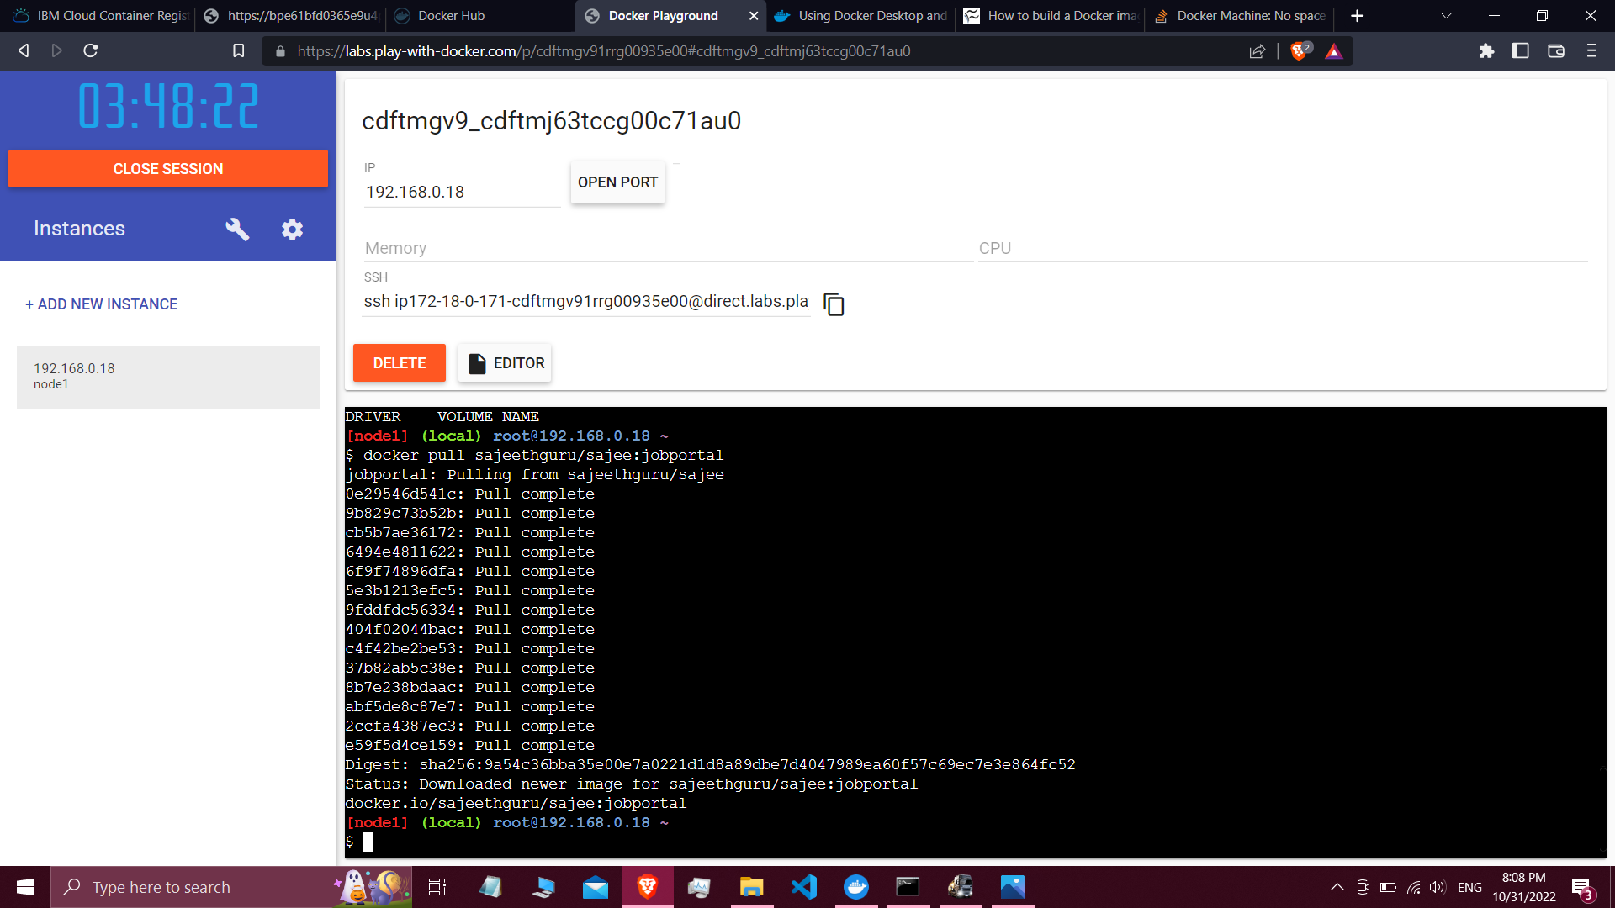

=> Running the pulled image:

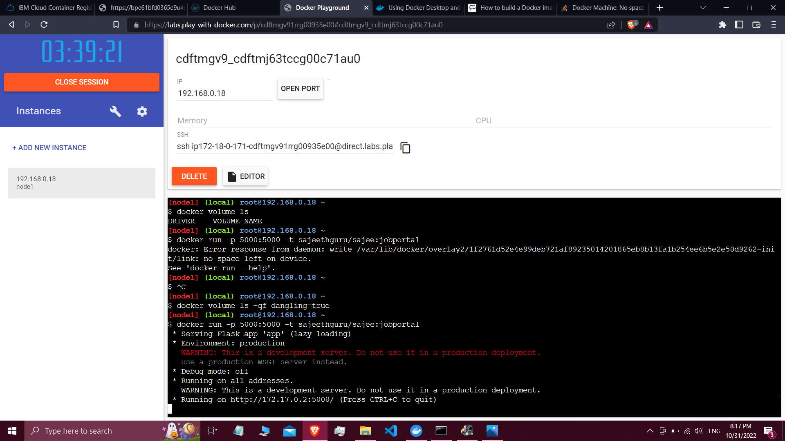

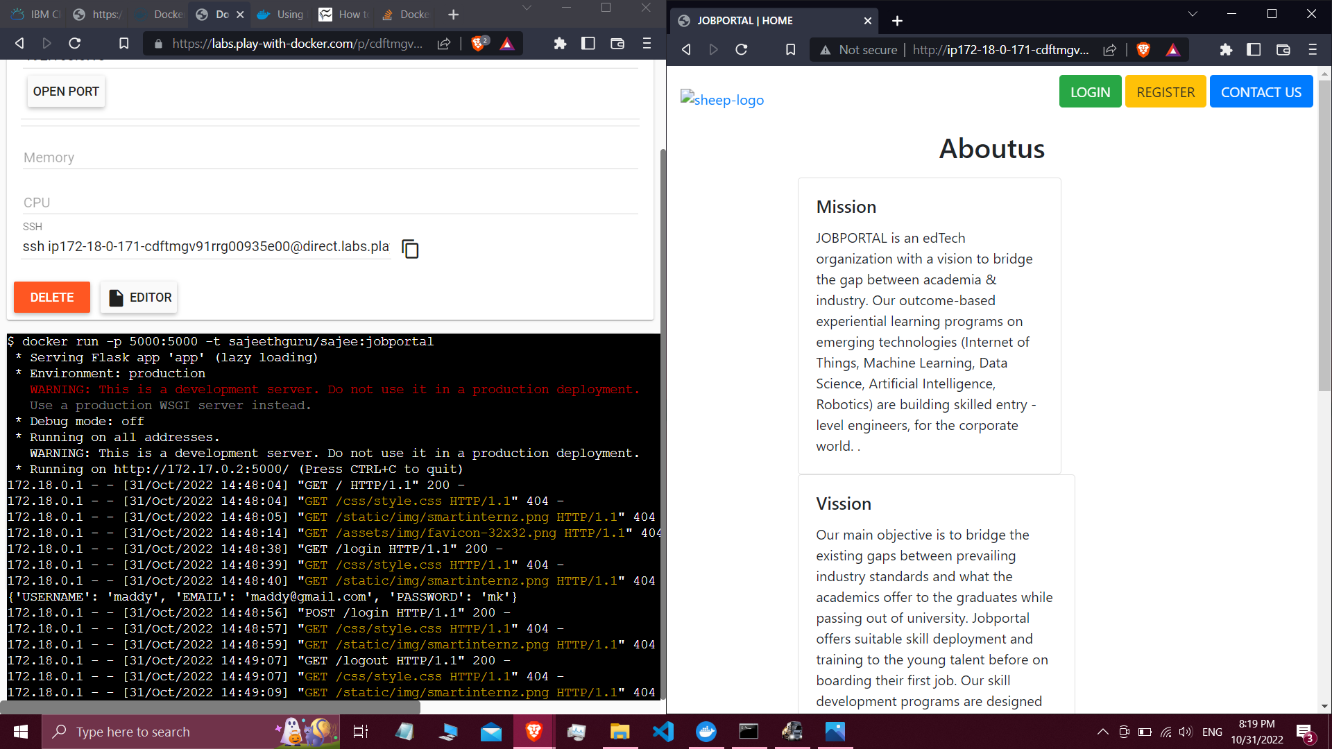

3.Create a IBM Container Registry and deploy jobportal app:

=>Pushing image to Container registry:

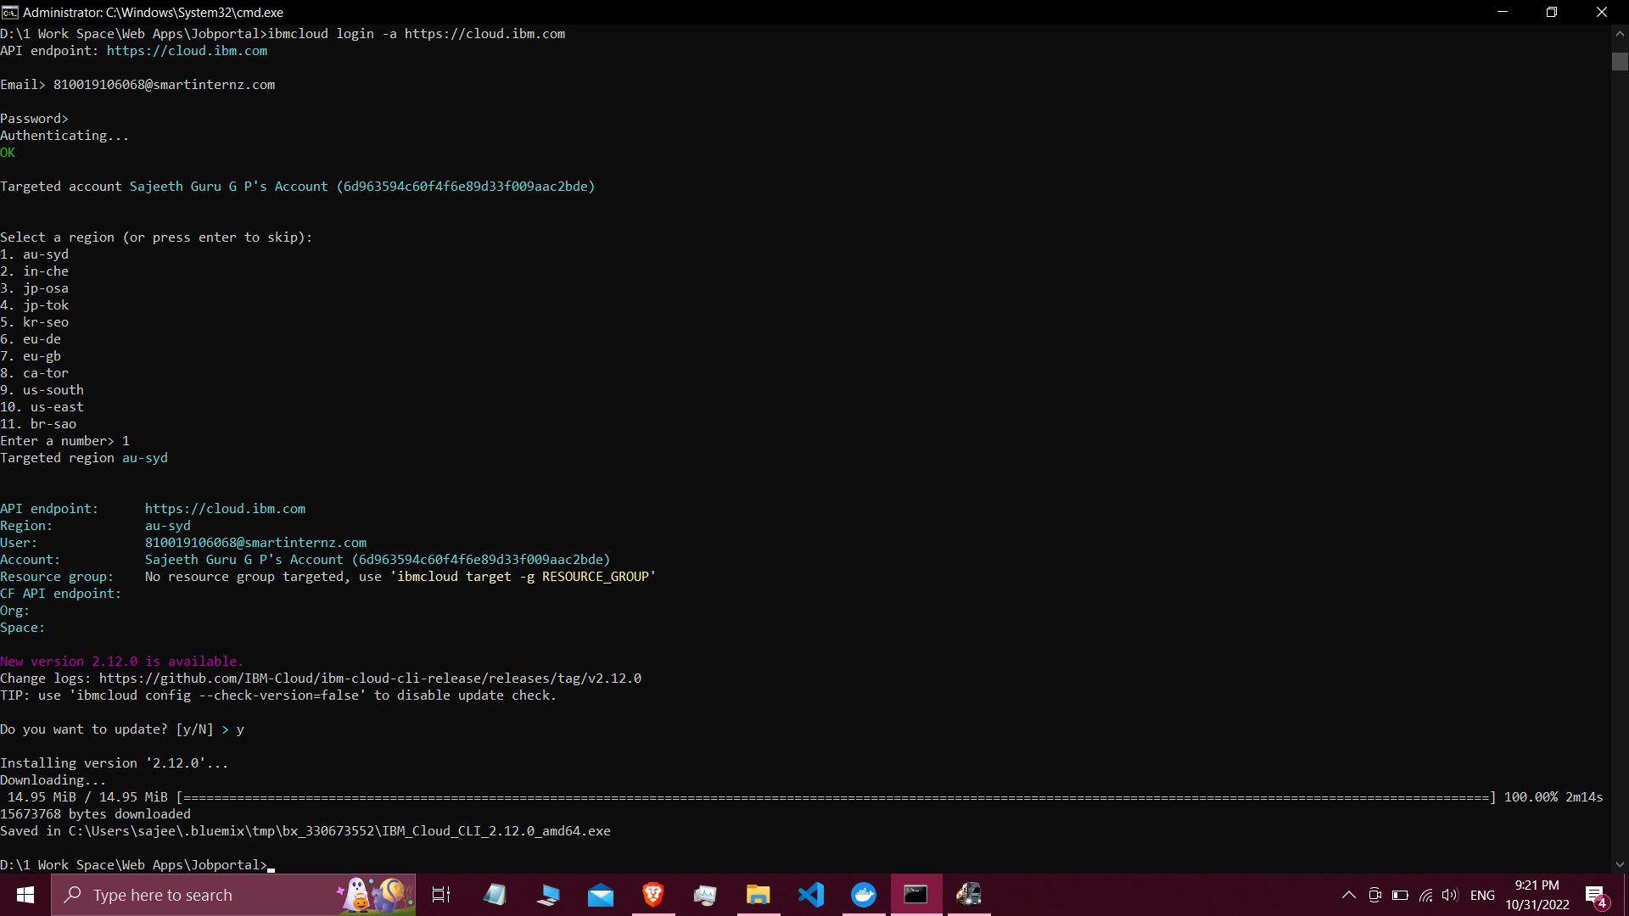

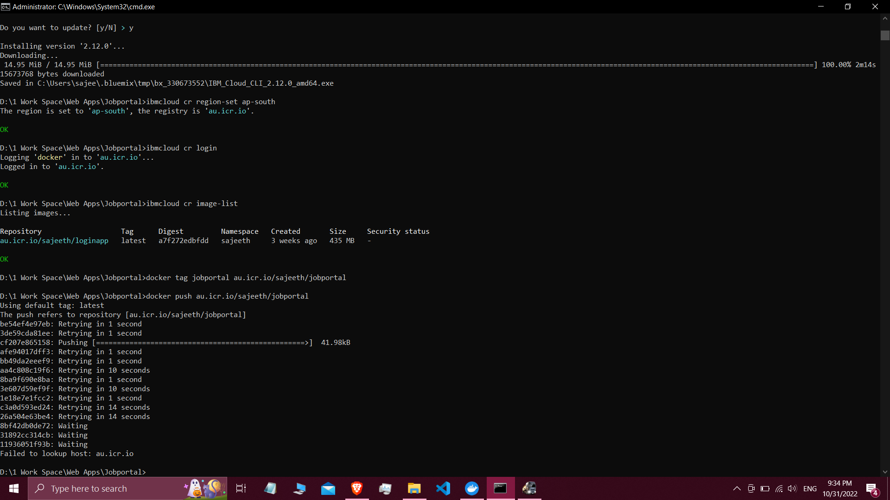

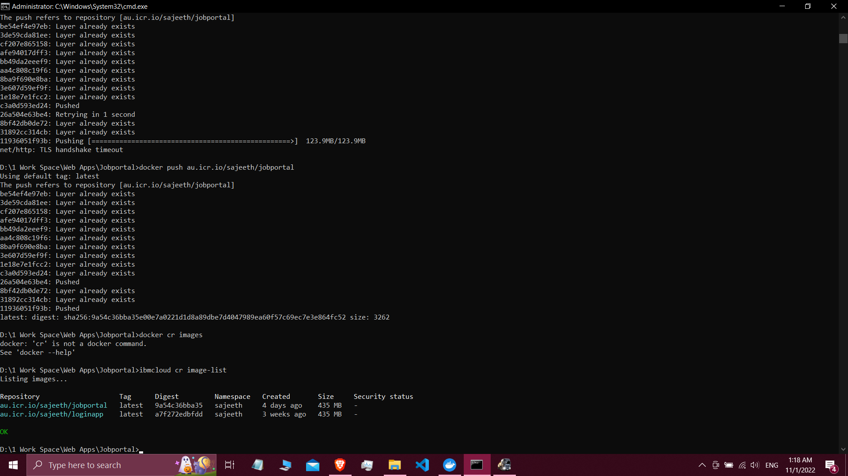

4.Create a Kubernetes cluster in IBM cloud and deploy jobportal image and also expose the same app to run in nodeportal:

=> deploying and exposing jobportal image into kubernetes cluster:

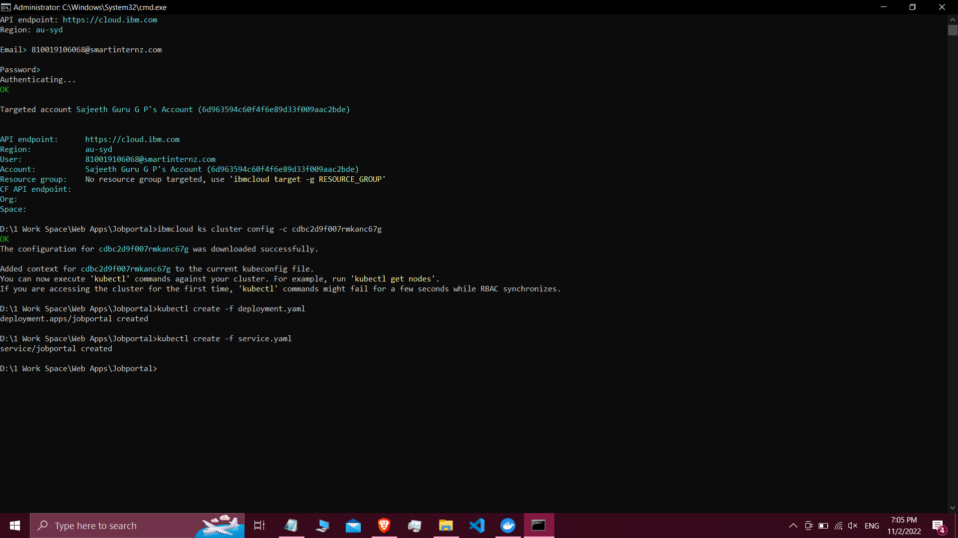

=>Running the app in nodeport:

